1. **Namakan main file as BengkelPHP.**

**Coding yg kena ada dalam file BengkelPHP**

**CONFIG – config.php**

<?php

$host = "localhost";

$username = "root";

$password = "root";

$db_name = "bengkel";

$connect = new mysqli($host, $username, $password, $db_name );

if ($connect->connect_errno)

{

echo "Failed to connect to MySQL:".$connect->error;

}

?>

**LOGIN – login.php**

<?php

session_start();

include('config.php');

//If button login click

if(isset($_POST['login']))

{

//Field variable declaration

$username = $_POST['username'];

$password = $_POST['password'];

//Code for login

$sql_login_pentadbir="SELECT * FROM pentadbir WHERE pentadbir_username='".$username."' AND pentadbir_password='".$password."'";

if ($result_login_pentadbir = $connect->query($sql_login_pentadbir))

{

$rows_login_pentadbir = $result_login_pentadbir->fetch_array();

if($total_login_pentadbir = $result_login_pentadbir->num_rows)

{

$_SESSION['pentadbir_id'] = $rows_login_pentadbir['pentadbir_id'];

echo "<script language=javascript>window.location='pentadbir/index.php';</script>";

}

else

{

$sql_login_pelajar="SELECT * FROM pelajar WHERE pelajar_username='".$username."' AND pelajar_password='".$password."'";

if ($result_login_pelajar = $connect->query($sql_login_pelajar))

{

$rows_login_pelajar = $result_login_pelajar->fetch_array();

if($total_login_pelajar = $result_login_pelajar->num_rows)

{

$_SESSION['pelajar_id'] = $rows_login_pelajar['pelajar_id'];

echo "<script language=javascript>window.location='pelajar/index.php';</script>";

}

}

}

}

}

?>

<header>

<title>BengkelPHP</title>

</header>

<html>

<body>

<form method= "post">

<h2>Login</h2>

Username : <input type = "text" name = "username" /> <br/><br/>

Password : <input type = "password" name = "password" /> <br/><br/>

<input type = "submit" name="login" value = "Login"/>

<input type = "reset" value = "Reset"/>

</form>

</body>

</html>

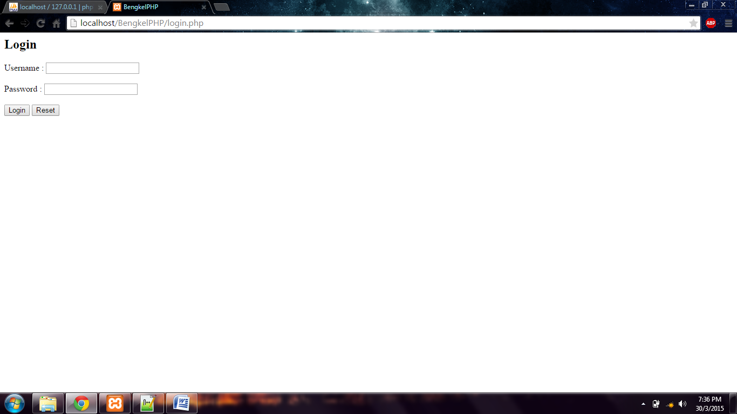

1. **Next, create file PENTADBIR dalam file BengkelPHP tadi.**

**Coding yg kena ada dalam file PENTADBIR**

**INDEX – index.php**

<?php

session_start();

include('../config.php');

if(!isset($_SESSION[pentadbir_id]))

{

echo "<script language=javascript>alert('Sila log in terlebih dahulu.');window.location='../login.php';</script>";

}

if($_GET['action']=="logout")

{

unset($_SESSION['pentadbir_id']);

echo "<script language=javascript>alert('Log keluar berjaya.');window.location='../login.php';</script>";

}

$sql_pentadbir = "SELECT * FROM pentadbir WHERE pentadbir_id = '".$_SESSION['pentadbir_id']."'";

if($result_pentadbir = $connect->query($sql_pentadbir))

{

$rows_pentadbir = $result_pentadbir->fetch_array();

$total_pentadbir = $result_pentadbir->num_rows;

}

$sql_pelajar = "SELECT * FROM pelajar";

if($result_pelajar = $connect->query($sql_pelajar))

{

$rows_pelajar = $result_pelajar->fetch_array();

$total_pelajar = $result_pelajar->num_rows;

$num_pelajar = 0;

}

?>

<header>

<title>Pentadbir</title>

</header>

<html>

<body>

Log Masuk : <?php echo $rows_pentadbir['pentadbir_nama']; ?><br/>

<a href = "index.php?action=logout">Log Keluar</a>

<hr/>

<a href="addstudent.php"><button>Tambah Pelajar</button></a>

<table border = '2' align="center" cellpadding="5" cellspacing="0">

<tr style="background: #9966ff">

<td >Bil</td>

<td align="center">Nama pelajar</td>

<td align="center">Alamat emel</td>

<td align="center">Tepon</td>

<td>Action</td>

</tr>

<?php do { ?>

<tr>

<td><?php echo ++$num_pelajar; ?></td>

<td><?php echo $rows_pelajar['pelajar_nama']; ?></td>

<td><?php echo $rows_pelajar['pelajar_email']; ?></td>

<td><?php echo $rows_pelajar['pelajar_notelefon']; ?></td>

<td>

<a href="viewstudent.php?id=<?php echo $rows_pelajar["pelajar_id"];?>"><button>View</button></a>

<a href="editstudent.php?id=<?php echo $rows_pelajar["pelajar_id"];?>"><button>Edit</button></a>

<a href="deletestudent.php?id=<?php echo $rows_pelajar["pelajar_id"];?>"><button>Delete</button></a>

</td>

<?php } while($rows_pelajar = $result_pelajar->fetch_array()); ?>

</tr>

</table>

<b><p align = "center">Rekod pelajar sebanyak <?php echo $total_pelajar ?></p></b>

</html>

</body>

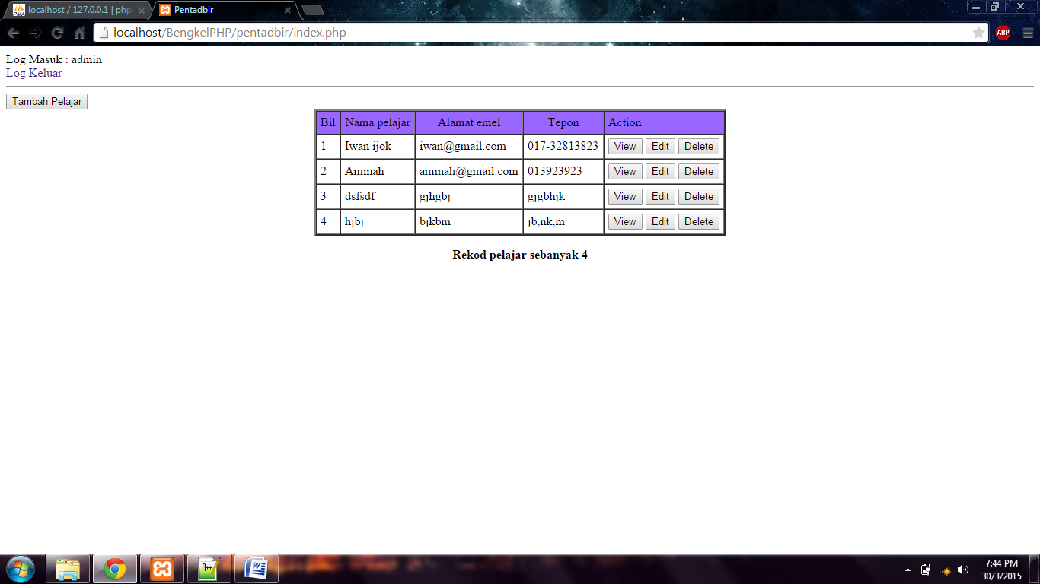

**ADD STUDENT – addstudent.php**

<?php

session_start();

include('../config.php');

if(!isset($_SESSION[pentadbir_id]))

{

echo "<script language=javascript>alert('Sila log in terlebih dahulu.');window.location='../login.php';</script>";

}

if($_GET['action']=="logout")

{

unset($_SESSION['pentadbir_id']);

echo "<script language=javascript>alert('Log keluar berjaya.');window.location='../login.php';</script>";

}

$sql_pentadbir = "SELECT * FROM pentadbir WHERE pentadbir_id = '".$_SESSION['pentadbir_id']."'";

if($result_pentadbir = $connect->query($sql_pentadbir))

{

$rows_pentadbir = $result_pentadbir->fetch_array();

$total_pentadbir = $result_pentadbir->num_rows;

}

$sql_pelajar = "SELECT * FROM pelajar WHERE pelajar_id = ".$_GET['id']."";

if($result_pelajar = $connect->query($sql_pelajar))

{

$rows_pelajar = $result_pelajar->fetch_array();

if(!$total_pelajar = $result_pelajar->num_rows)

{

echo "<script language=javascript>window.location='student-list.php';</script>";

}

}

else

{

echo "<script language=javascript window.location='student-list.php';</script>";

}

?>

<header>

<title>Maklumat Pelajar</title>

</header>

<html>

<body>

<h1>Maklumat Pelajar</h1><hr/>

Nama Pelajar : <?php echo $rows_pelajar['pelajar_nama']; ?> </br>

Alamat Email : <?php echo $rows_pelajar['pelajar_email']; ?> </br>

No Telefon : <?php echo $rows_pelajar['pelajar_notelefon']; ?> </br>

Alamat : <?php echo $rows_pelajar['pelajar_alamat']; ?> </br>

Daerah : <?php echo $rows_pelajar['pelajar_daerah']; ?> </br>

Poskod : <?php echo $rows_pelajar['pelajar_poskod']; ?> </br>

Negeri : <?php echo $rows_pelajar['pelajar_negeri']; ?> </br>

Username : <?php echo $rows_pelajar['pelajar_username']; ?></br>

Password : <?php echo $rows_pelajar['pelajar_password']; ?></br>

Gambar : </br>

</html>

</body>

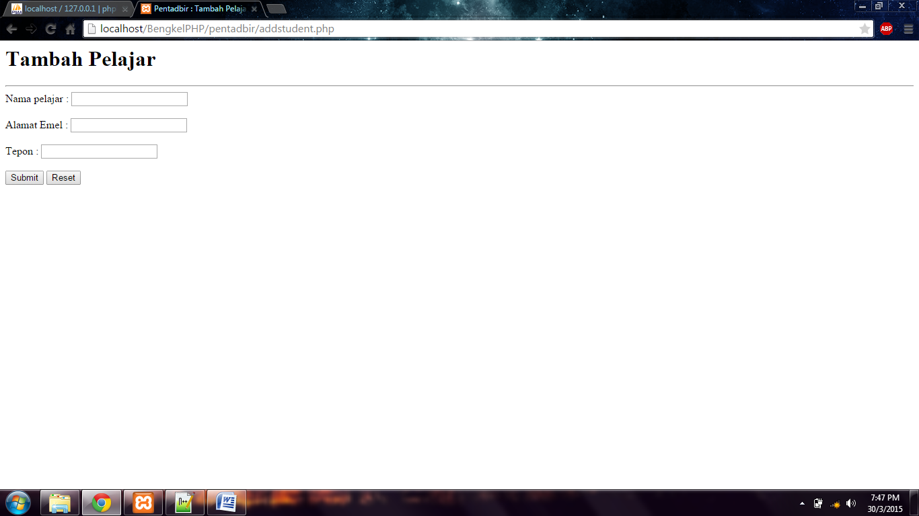

**VIEW STUDENT – viewstudent.php**

<?php

session_start();

include('../config.php');

if(!isset($_SESSION[pentadbir_id]))

{

echo "<script language=javascript>alert('Sila log in terlebih dahulu.');window.location='../login.php';</script>";

}

if($_GET['action']=="logout")

{

unset($_SESSION['pentadbir_id']);

echo "<script language=javascript>alert('Log keluar berjaya.');window.location='../login.php';</script>";

}

$sql_pentadbir = "SELECT * FROM pentadbir WHERE pentadbir_id = '".$_SESSION['pentadbir_id']."'";

if($result_pentadbir = $connect->query($sql_pentadbir))

{

$rows_pentadbir = $result_pentadbir->fetch_array();

$total_pentadbir = $result_pentadbir->num_rows;

}

$sql_pelajar = "SELECT * FROM pelajar WHERE pelajar_id = ".$_GET['id']."";

if($result_pelajar = $connect->query($sql_pelajar))

{

$rows_pelajar = $result_pelajar->fetch_array();

if(!$total_pelajar = $result_pelajar->num_rows)

{

echo "<script language=javascript>window.location='student-list.php';</script>";

}

}

else

{

echo "<script language=javascript window.location='student-list.php';</script>";

}

?>

<header>

<title>Maklumat Pelajar</title>

</header>

<html>

<body>

<h1>Maklumat Pelajar</h1><hr/>

Nama Pelajar : <?php echo $rows_pelajar['pelajar_nama']; ?> </br>

Alamat Email : <?php echo $rows_pelajar['pelajar_email']; ?> </br>

No Telefon : <?php echo $rows_pelajar['pelajar_notelefon']; ?> </br>

Alamat : <?php echo $rows_pelajar['pelajar_alamat']; ?> </br>

Daerah : <?php echo $rows_pelajar['pelajar_daerah']; ?> </br>

Poskod : <?php echo $rows_pelajar['pelajar_poskod']; ?> </br>

Negeri : <?php echo $rows_pelajar['pelajar_negeri']; ?> </br>

Username : <?php echo $rows_pelajar['pelajar_username']; ?></br>

Password : <?php echo $rows_pelajar['pelajar_password']; ?></br>

Gambar : </br>

</html>

</body>

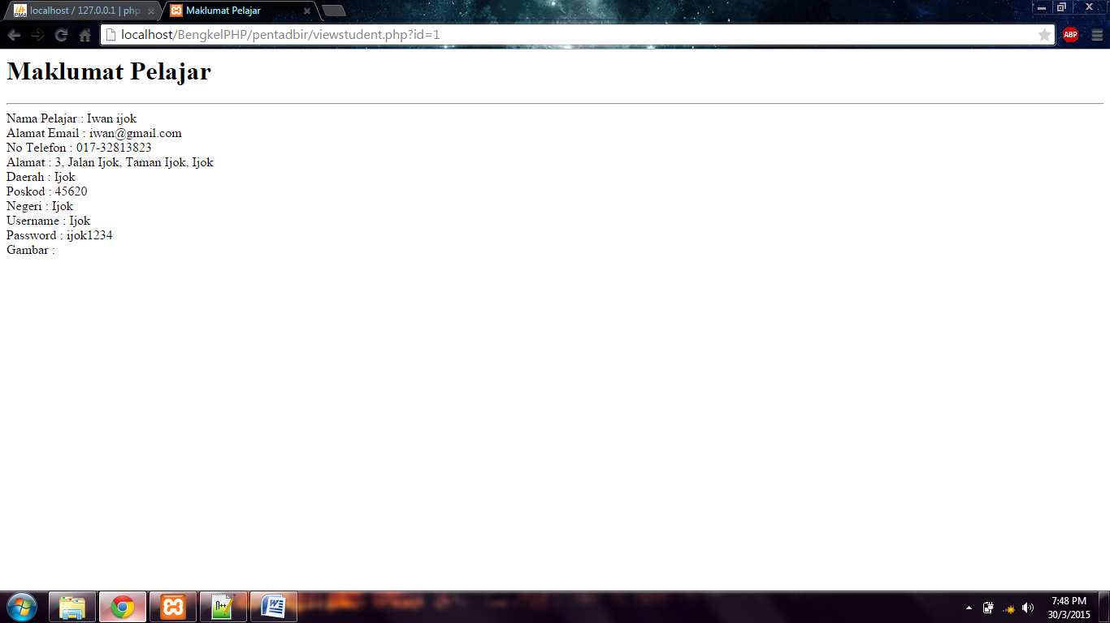

**EDIT STUDENT – editstudent.php**

<?php

session_start();

include('../config.php');

if(!isset($_SESSION[pentadbir_id]))

{

echo "<script language=javascript>alert('Sila log in terlebih dahulu.');window.location='../login.php';</script>";

}

if($_GET['action']=="logout")

{

unset($_SESSION['pentadbir_id']);

echo "<script language=javascript>alert('Log keluar berjaya.');window.location='../login.php';</script>";

}

$sql_pentadbir = "SELECT * FROM pentadbir WHERE pentadbir_id = '".$_SESSION['pentadbir_id']."'";

if($result_pentadbir = $connect->query($sql_pentadbir))

{

$rows_pentadbir = $result_pentadbir->fetch_array();

$total_pentadbir = $result_pentadbir->num_rows;

}

$sql_pelajar = "SELECT * FROM pelajar WHERE pelajar_id = ".$_GET['id']."";

if($result_pelajar = $connect->query($sql_pelajar))

{

$rows_pelajar = $result_pelajar->fetch_array();

if(!$total_pelajar = $result_pelajar->num_rows)

{

echo "<script language=javascript>window.location='student-list.php';</script>";

}

}

else

{

echo "<script language=javascript window.location='student-list.php';</script>";

}

if (isset($_POST['edit']))

{

$nama = $_POST['nama'];

//die("UPDATE pelajar SET pelajar_nama = '$nama' WHERE pelajar_id = '".$_GET['id']."'");

$sql_edit_pelajar="UPDATE pelajar SET pelajar_nama = '$nama' WHERE pelajar_id = '".$_GET['id']."'";

if($result_edit_pelajar = $connect->query($sql_edit_pelajar))

{

echo "<script language=javascript>alert('Maklumat berjaya dikemaskini.');window.location='viewstudent.php?id=".$_GET['id']."';</script>";

}

else

{

echo "<script language=javascript>alert('Maklumat tidak berjaya dikemaskini. Sila cuba lagi');window.location='editstudent.php';</script>";

}

}

?>

<header>

<title>Maklumat Pelajar</title>

</header>

<html>

<body>

<h1>Kemaskini Maklumat Pelajar</h1><hr/>

<form method="post">

Nama Pelajar : <input type="text" name="nama" value="<?php echo $rows_pelajar['pelajar_nama']; ?>" /> </br></br>

Alamat Email : <input type="text" name="emel" value="<?php echo $rows_pelajar['pelajar_email']; ?>" /> </br></br>

No Telefon : <input type="text" name="tepon" value="<?php echo $rows_pelajar['pelajar_notelefon']; ?>" /> </br></br>

Alamat : <input type="text" name="alamat" value="<?php echo $rows_pelajar['pelajar_alamat']; ?>" /> </br></br>

Daerah : <input type="text" name="daerah" value="<?php echo $rows_pelajar['pelajar_daerah']; ?>" /> </br></br>

Poskod : <input type="text" name="poskod" value="<?php echo $rows_pelajar['pelajar_poskod']; ?>" /> </br></br>

Negeri : <input type="text" name="negeri" value="<?php echo $rows_pelajar['pelajar_negeri']; ?>" /> </br></br>

Username : <input type="text" name="username" value="<?php echo $rows_pelajar['pelajar_username']; ?>" /></br></br>

Password : <input type="text" name="password" value="<?php echo $rows_pelajar['pelajar_password']; ?>" /></br></br>

Gambar : </br></br>

<input type = "submit" name="edit" value = "Submit"/>

<input type = "reset" value = "Reset"/>

</html>

</body>

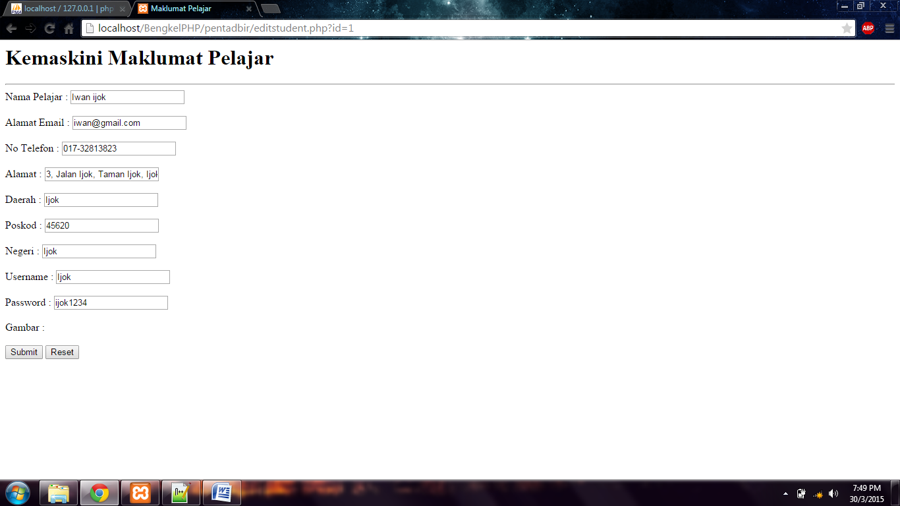

**DELETE STUDENT – deletestudent.php**

<?php

session_start();

include('../config.php');

$sql_padam_pelajar = "DELETE FROM pelajar WHERE pelajar_id = ".$_GET['id']."";

if($result_padam_pelajar = $connect->query($sql_padam_pelajar))

{

echo "<script language=javascript>alert('Maklumat berjaya dipadam.');window.location='index.php';</script>";

}

else

{

echo "<script language=javascript>alert('Maklumat tidak berjaya dipadam. Sila cuba lagi');window.location='index.php';</script>";

}

?>

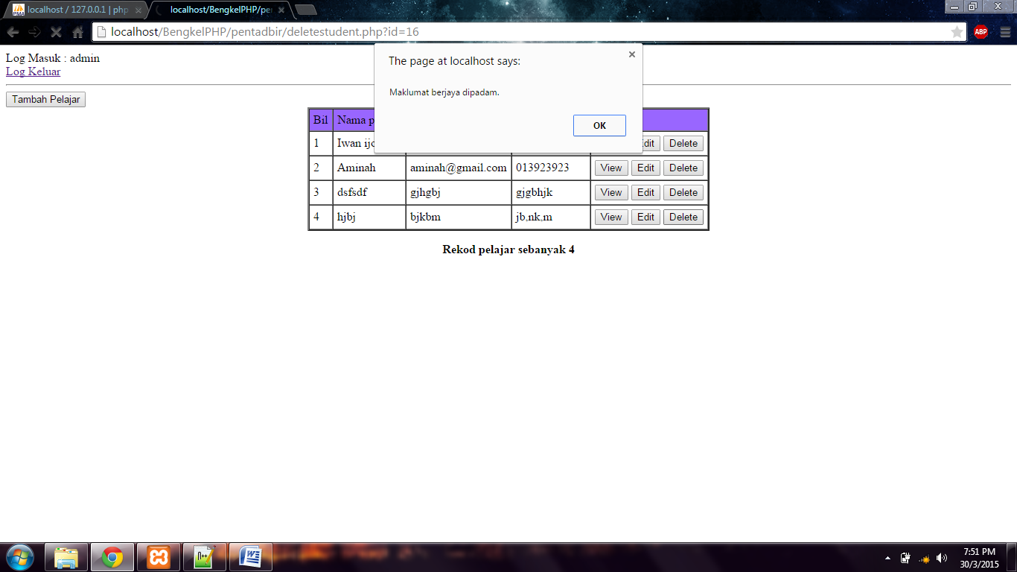

1. **Namakan main file as pelajar.**

**Coding yg kena ada dalam file PELAJAR**

**INDEX – index.php**

<?php

session_start();

include('../config.php');

if(!isset($_SESSION['pelajar_id']))

{

echo "<script language=javascript>alert('Sila log in terlebih dahulu.');window.location='../login.php';</script>";

}

if($_GET['action']=="logout")

{

unset($_SESSION['pelajar_id']);

echo "<script language=javascript>alert('Log keluar berjaya.');window.location='../login.php';</script>";

}

$sql_pelajar = "SELECT * FROM pelajar WHERE pelajar_id = '".$_SESSION['pelajar_id']."'";

if($result_pelajar = $connect->query($sql_pelajar))

{

$rows_pelajar = $result_pelajar->fetch_array();

$total_pelajar = $result_pelajar->num_rows;

}

?>

<header>

<title>Pelajar</title>

</header>

<html>

<body>

Log Masuk :<?php echo $rows_pelajar['pelajar_nama']; ?> <br/>

<a href = "index.php?action=logout">Log Keluar</a>

</html>

</body>

